Table S3. List of primers used in the study.
F108AF | 5'- CTTGCAGGGATCTGGGGCCGCACAGGTGCCAAAT -3’
F108AR | 5'- ATTTGGCACCTGTGCGGCCCCAGATCCCTGCAAG -3’
P109AF | 5'- CTTGCAGGGATCTGCGAACGCACAGGTGC -3’
P109AR | 5'- GCACCTGTGCGTTCGCAGATCCCTGCAAG -3'
D110AF | 5'- ATATATTCTTGCAGGGAGCTGGGAACGCACAGGTG -3'
D110AR | 5'- CACCTGTGCGTTCCCAGCTCCCTGCAAGAATATAT -3'
P111AF | 5'- AATATATTCTTGCAGGCATCTGGGAACGCACAGGT -3'
P111AR | 5'- ACCTGTGCGTTCCCAGATGCCTGCAAGAATATATT -3'
C112AF | 5'- ACCTGGAAAATATATTCTTGGCGGGATCTGGGAACGCACAG -3'
C112AR | 5'- CTGTGCGTTCCCAGATCCCGCCAAGAATATATTTTCCAGGT -3'
K113AF | 5'- AAAAACCTGGAAAATATATTCGCGCAGGGATCTGGGAACGCAC -3'
K113AR | 5'- GTGCGTTCCCAGATCCCTGCGCGAATATATTTTCCAGGTTTTT -3'
N114AF | 5'- GAAAAAAACCTGGAAAATATAGCCTTGCAGGGATCTGGGAACGC -3'
N114AR | 5'- GCGTTCCCAGATCCCTGCAAGGCTATATTTTCCAGGTTTTTTTC -3'
I115AF | 5'- AGTAAGAAAAAAACCTGGAAAATGCATTCTTGCAGGGATCTGGGAACG -3'
I115AR | 5'- CGTTCCCAGATCCCTGCAAGAATGCATTTTCCAGGTTTTTTTCTTACT -3'
F116AF | 5'- GAAAAAAACCTGGAAGCTATATTCTTGCAGGGATCTGGGAACGC -3'
F116AR | 5'- GCGTTCCCAGATCCCTGCAAGAATATAGCTTCCAGGTTTTTTTC -3'
S117AF | 5'- GTAAGAAAAAAACCTGGCAAATATATTCTTGCAGGGATCTGGGAAC -3'
S117AR | 5'- GTTCCCAGATCCCTGCAAGAATATATTTGCCAGGTTTTTTTCTTAC -3'
R118AF | 5'- CCCTCGGAAGTAAGAAAAAAACGCGGAAAATATATTCTTGCAGGGA -3'
R118AR | 5'- TCCCTGCAAGAATATATTTTCCGCGTTTTTTTCTTACTTCCGAGGG -3'
F119AF | 5'- CACCCCTCGGAAGTAAGAAAAAGCCCTGGAAAATATATTCTTGCAG -3’
F119AR | 5'- CTGCAAGAATATATTTTCCAGGGCTTTTTCTTACTTCCGAGGGGTG -3’
F120AF | 5'- CCACCCCTCGGAAGTAAGAAGCAAACCTGGAAAATATATTCTTGC -3’
F120AR | 5'- GCAAGAATATATTTTCCAGGTTTGCTTCTTACTTCCGAGGGGTGG -3’
S121AF | 5'- CCACCCCTCGGAAGTAAGCAAAAAACCTGGAAAATATATTCTTG -3’
S121AR | 5'- CAAGAATATATTTTCCAGGTTTTTTGCTTACTTCCGAGGGGTGG -3’
Y122AF | 5'- ACCTCCACCCCTCGGAAGGCAGAAAAAAACCTGGAAAATATATTCT -3’
Y122AR | 5'- AGAATATATTTTCCAGGTTTTTTTCTGCCTTCCGAGGGGTGGAGGT -3’
F123AF | 5'-GACCTCCACCCCTCGGGCGTAAGAAAAAAACCTGGAAAATATA -3’
F123AR | 5'- TATATTTTCCAGGTTTTTTTCTTACGCCCGAGGGGTGGAGGTC -3’
R124AF | 5'- GTGACCTCCACCCCTGCGAAGTAAGAAAAAAACCTGGAA -3’
R124AR | 5'- TTCCAGGTTTTTTTCTTACTTCGCAGGGGTGGAGGTCAC -3’
G125AF | 5’- GTGACCTCCACCGCTCGGAAGTAAGAAAAAAACCTGGAA -3’
G125AR | 5’- TTCCAGGTTTTTTTCTTACTTCCGAGCGGTGGAGGTCAC -3’
D110VF | 5’- ATATATTCTTGCAGGGAACTGGGAACGCACAGGTG -3’
D110VR | 5’- CACCTGTGCGTTCCCAGTTCCCTGCAAGAATATAT
P111HF | 5’- GTGCGTTCCCAGATCACTGCAAGAATATATTTTCC -3’
P111HR | 5’- GGAAAATATATTCTTGCAGTGATCTGGGAACGCAC -3’
N114HF | 5’- GATCCCTGCAAGCATATATTTTCCAGG -3’
N114HR | 5’- CCTGGAAAATATATGCTTGCAGGGATC -3’
I115TF | 5’- AAAAAAACCTGGAAAACGTATTCTTGCAGGGATCTGGGAACGC -3’
I115TR | 5’- GCGTTCCCAGATCCCTGCAAGAATACGTTTTCCAGGTTTTTTTC -3’
R118SF | 5’- CCCTCGGAAGTAAGAAAAAAAGCTGGAAAATATATTCTTGCAG -3’
R118SR | 5’- CTGCAAGAATATATTTTCCAGCTTTTTTTCTTACTTCCGAGGG -3’
S121LF | 5’- TCCAGGTTTTTTCTCTACTTCCGAGGG -3’
S121LR | 5’- CCCTCGGAAGTAGAGAAAAAACCTGGA -3’
108_125RPE65Fwd | 5’- TACTTCCAATCCAATGCATTCCCAGATCCCTGCAAG -3’
108_125RPE65Rev | 5’- TTATCCACTTCCAATGTTATTACCCTCGGAAGTAAG-3’

Figure S1.
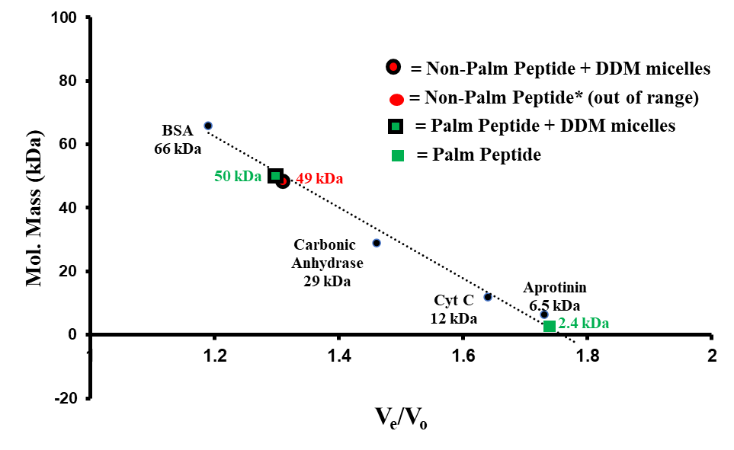

Figure S2. Pathogenic mutations/variants of unknown significance (VUS) in AH¹⁰⁷⁻¹²⁵ significantly impact the protein expression level of RPE65 protein.
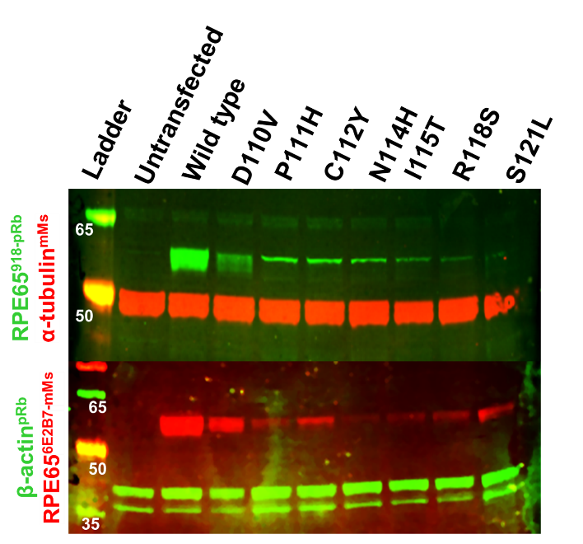
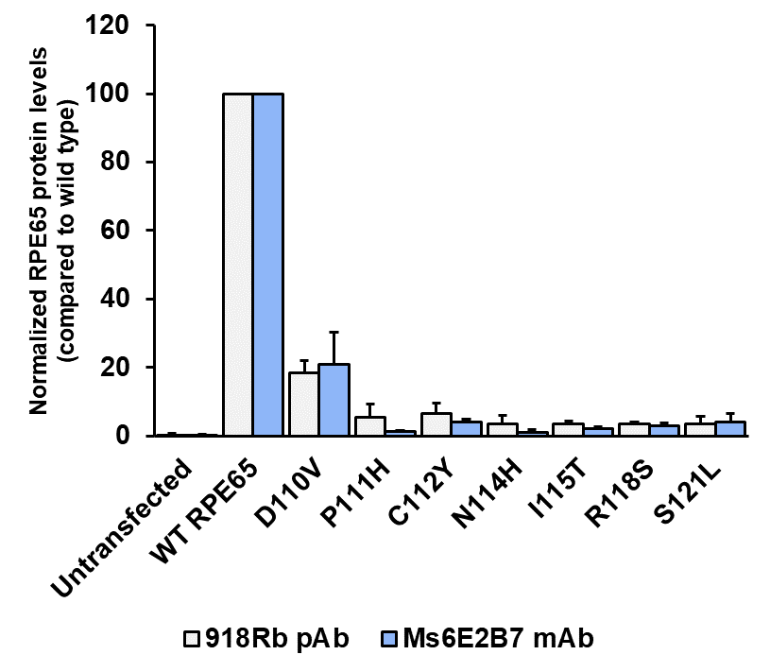

References

Chung, D.C., M. Bertelsen, B. Lorenz, M.E. Pennesi, B.P. Leroy, C.P. Hamel, E. Pierce, J. Sallum, M. Larsen, K. Stieger, M. Preising, R. Weleber, P. Yang, E. Place, E. Liu, G. Schaefer, J. DiStefano-Pappas, O.U. Elci, S. McCague, J.A. Wellman, K.A. High, and K.Z. Reape. 2019. The Natural History of Inherited Retinal Dystrophy Due to Biallelic Mutations in the RPE65 Gene. Am J Ophthalmol. 199:58-70.
Henderson, R.H., N. Waseem, R. Searle, J. van der Spuy, I. Russell-Eggitt, S.S. Bhattacharya, D.A. Thompson, G.E. Holder, M.E. Cheetham, A.R. Webster, and A.T. Moore. 2007. An assessment of the apex microarray technology in genotyping patients with Leber congenital amaurosis and early-onset severe retinal dystrophy. Invest Ophthalmol Vis Sci. 48:5684-5689.
Li, S., X. Xiao, Z. Yi, W. Sun, P. Wang, and Q. Zhang. 2020. RPE65 mutation frequency and phenotypic variation according to exome sequencing in a tertiary centre for genetic eye diseases in China. Acta Ophthalmol. 98:e181-e190.
Liu, X., T. Tao, L. Zhao, G. Li, and L. Yang. 2021. Molecular diagnosis based on comprehensive genetic testing in 800 Chinese families with non-syndromic inherited retinal dystrophies. Clin Exp Ophthalmol. 49:46-59.
Pasadhika, S., G.A. Fishman, E.M. Stone, M. Lindeman, R. Zelkha, I. Lopez, R.K. Koenekoop, and M. Shahidi. 2010. Differential macular morphology in patients with RPE65-, CEP290-, GUCY2D-, and AIPL1-related Leber congenital amaurosis. Invest Ophthalmol Vis Sci. 51:2608-2614.
Schatz, P., M. Preising, B. Lorenz, B. Sander, M. Larsen, and T. Rosenberg. 2011. Fundus albipunctatus associated with compound heterozygous mutations in RPE65. Ophthalmology. 118:888-894.
Stone, E.M. 2007. Leber congenital amaurosis - a model for efficient genetic testing of heterogeneous disorders: LXIV Edward Jackson Memorial Lecture. Am J Ophthalmol. 144:791-811.
Verma, A., V. Perumalsamy, S. Shetty, M. Kulm, and P. Sundaresan. 2013. Mutational screening of LCA genes emphasizing RPE65 in South Indian cohort of patients. PLoS One. 8:e73172.
Wang, J., V.W. Zhang, Y. Feng, X. Tian, F.Y. Li, C. Truong, G. Wang, P.W. Chiang, R.A. Lewis, and L.J. Wong. 2014. Dependable and efficient clinical utility of target capture-based deep sequencing in molecular diagnosis of retinitis pigmentosa. Invest Ophthalmol Vis Sci. 55:6213-6223.
Wiszniewski, W., R.A. Lewis, D.W. Stockton, J. Peng, G. Mardon, R. Chen, and J.R. Lupski. 2011. Potential involvement of more than one locus in trait manifestation for individuals with Leber congenital amaurosis. Hum Genet. 129:319-327.
Zhong, Z., F. Rong, Y. Dai, A. Yibulayin, L. Zeng, J. Liao, L. Wang, Z. Huang, Z. Zhou, and J. Chen. 2019. Seven novel variants expand the spectrum of RPE65-related Leber congenital amaurosis in the Chinese population. Mol Vis. 25:204-214.

